**Out of Context: ~~Frieza~~ Freeza Day Special**

V1.04 By DeverosSphere

How many times must I tell you? There is no "I" in "Freeza"!

This document can be used as a supplement in any Jump that would not otherwise have “Freeza Day, the most explodiest time of the year!” within its continuity.

By taking this Supplement you have chosen to participate and promote the “holiday” event of Freeza Day to the masses of the setting’s world.

This “Holiday” was created by Freeza to replace Christmas and the celebrations are known to all planets in the Freeza Empire.

The first Freeza Day is known as the day Freeza blew up Planet Vegeta with each subsequent year Freeza celebrating by receiving gifts from all planets within their empire but those who give Freeza the worst gift or refuse to give any gift at all get to be Planet Vegeta for a day before getting blown up.

You will enter into that continuity as a Drop-In bursting out of a Freeza Day Present during a musical number that explains the event to those who are listening.

**+1000 CP**

If this Supplement is instead taken as an Isolated Jump you may select a setting of your choice even if it doesn’t have a Jump Document and use this document as a ten-year-long Jump.

# **Origin:**

What type of holiday celebrator are you and why are you trying to spread the Freeza Day cheer?

**Armored**

Oh, you're more interested in the events that take place rather than the reason for the season. The combination of action with a Freeza Day setting, such as a hostage situation or a fight against mercenaries while Lord Freeza opens gifts.

**Metal**

Nowadays people forget the true meaning of Freeza Day but not you!

You know the story of Freeza’s birth, the stupid monkeys, the journey of King Cold, his empire, and the special meaning of putting peons in their place.

**Gold**

It seems you're more interested in the glitz and glamor of the season which features themes of death, Genocide, and the spirit of blowing up planets. Some people focus on the unimportant things like resistance, existential dread, and the magic of not dying this year. 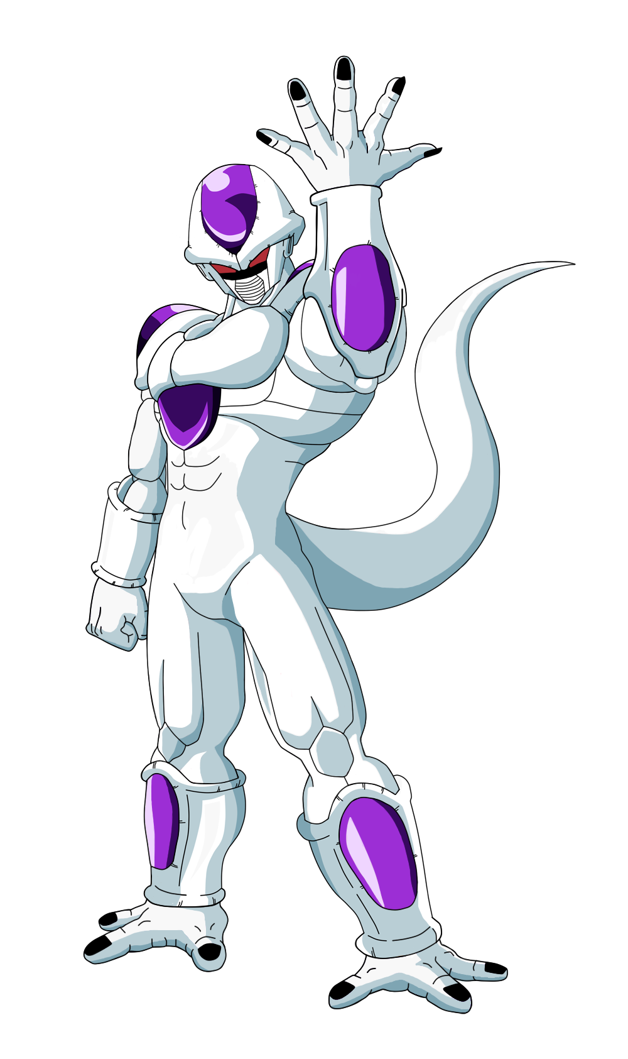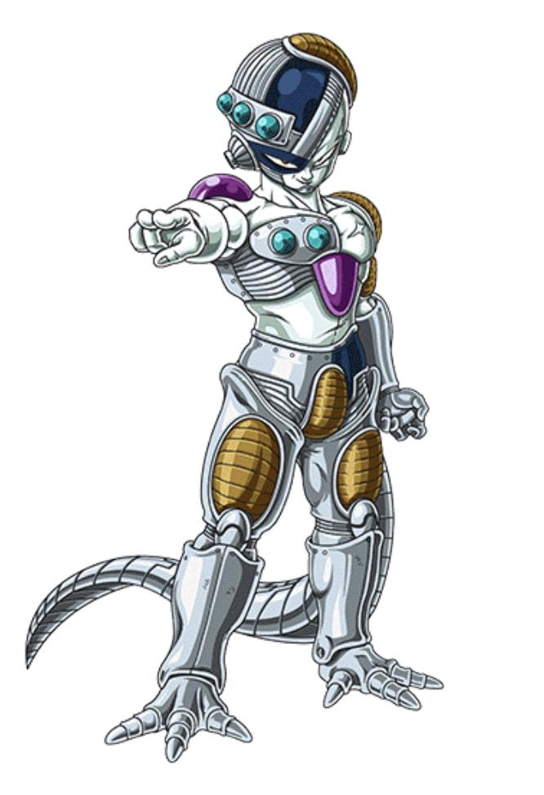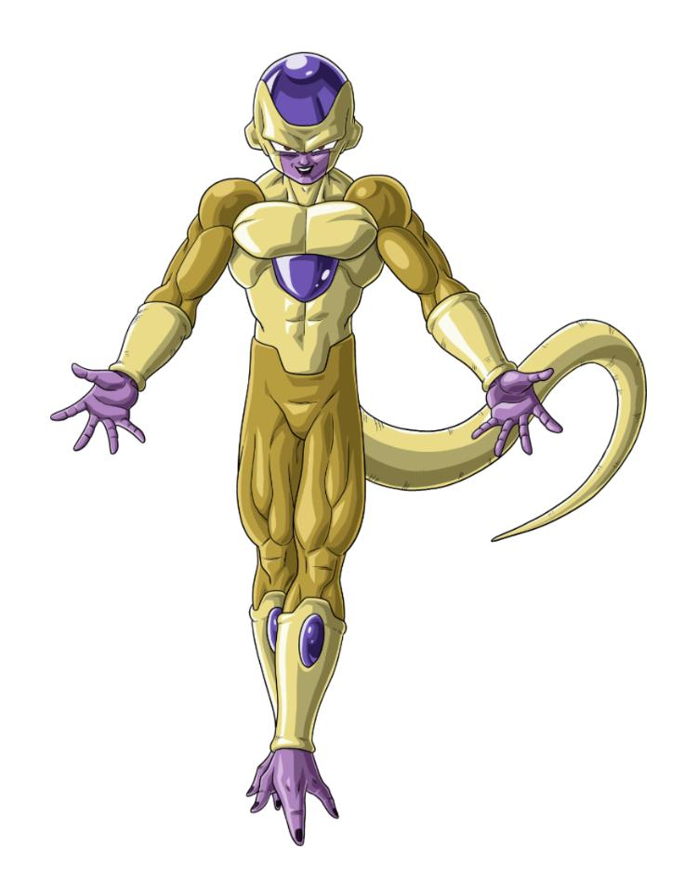

# 

# **Perks:**

**Perk Booster Demonstration:**

To get a **Booster:** Perk, you will need to purchase the stated Perks. As a **demonstration**:

**Something Rare -400 EP**

This Perk is an example of something rare that the subject of this OOCS can do.

**Almost Unique -600 EP**

This Perk would be an almost unique thing that the subject of this OOCS can do.

***Something Rare Booster: Something Unique***

This Perk is an example of something unique that the subject of this OOCS can do.

To get the Perk **Something Unique**, you need to take both the **Almost Unique** Perk that it follows and the **Something Rare** Perk that is commented before the boosted Perk.

## **General Perks:**

**A Freeza Story - Free (Cannot be taken with “Holiday Fanatic”)**

And how better to tell that story but in the language of its people and as you now say "Aloevi vi vivial", which as you know means "Let's get down to business”. You can now speak, understand, read, and write in the native language of Lord Freeza’s race.

**Miracle of Freeza Street - Free (Cannot be taken with “Holiday Fanatic”)**

It truly is a miracle you can go 40 days and 40 nights without food, water, oxygen, or sleep!

Well, you can go indefinitely without them while being exposed to Stellar Radiation but you will still find eating, drinking, breathing, and sleeping more pleasant than going without them.

**Form Alone: A Comedy Without Cooler - Free (Cannot be taken with “Holiday Fanatic”)**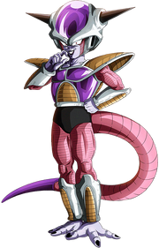

It seems that you wish to take the place of Lord Freeza in this holiday as you gain an **Alt-Form** similar to Freeza’s lowest restricted form. For the duration of this Jump you will be locked into this **Alt-Form** with your power level being restrained to 0.441666r% your normal power level. If your normal power level is less than 2,265 PL this form's power level will be 10 PL otherwise it will rise to match your proportional Power Level. Any training you do while in a power-restraining form will increase your Power Level proportionally. This **Alt-Form** has a short, lean build with red pupils, a white exoskeleton called a Bio-Suit, a long reptilian tail, three talon-like toes, horns that protrude at the 45-degree angle and colored gem-like plates on your head, torso, ankles, wrists, and shoulders. The exact colour scheme and shade will vary depending on the person.

**Form Alone 2: Lost in New Namek -100 CP (Requires “Form Alone: A Comedy Without Cooler”)**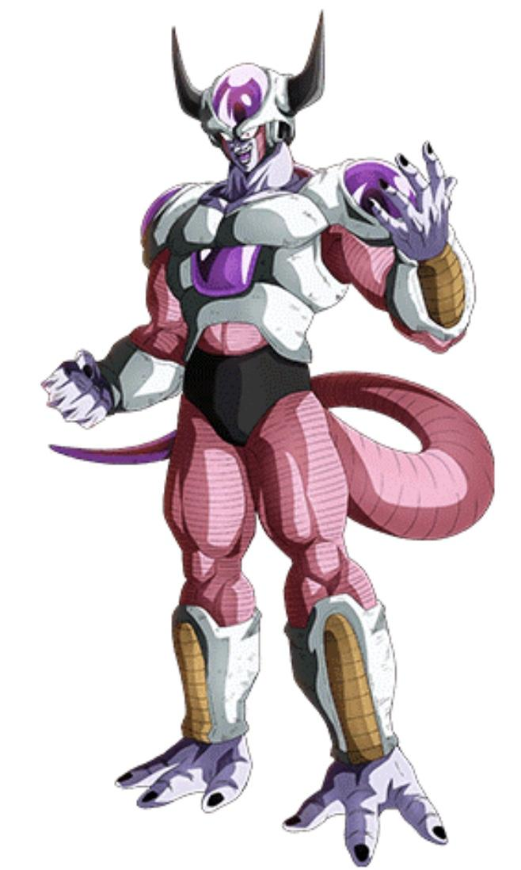

You are now able to transform into a more mature version of your First Form and while in this form your power level is restrained to 0.88333r% your normal power level. If your normal power level is less than 2,265 PL this form's power level will be 20 PL otherwise it will rise to match your proportional Power Level. This second form will look similar to your first, except it is noticeably taller, very muscular, and the horns grow longer curving sharply upwards into near right angles.

**Form Alone: The Ridley Scott Heist -100 CP (Requires “Form Alone 2: Lost in New Namek”)**

You are now able to transform into a less humanoid version of your Second Form and while in this form your power level is restrained to 1.7666% of your normal power level. If your normal power level is less than 2,265 PL this form's power level will be 40 PL otherwise it will rise to match your proportional Power Level. This third form will look similar to your second, however, it has an elongated head with facial features contorting and changing so that your nose melds into your mouth to form a crude beak and additional spikes sprout from your back.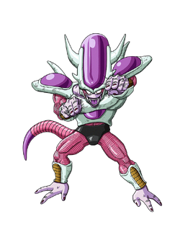

**Form Sweet Form Alone -100 CP (Requires “Form Alone: The Ridley Scott Heist”)**

You can now transform into your True Form and while in this form your power level is restrained to 2.666r% your normal power level. If your normal power level is less than 2,265 PL this form's power level will be 60 PL otherwise it will rise to match your proportional Power Level. This True Form will look similar to your first in terms of size and bulk but with a smoother Bio-Suit structure. Your version of this form could be completely white except for the coloured plates on the chest, head, shoulders, lower arms, and lower legs or you could have a coloured form with white parts on your joints.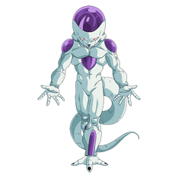

***Freeza Day All Over Again Booster: Have yourself a merry little Freeza Day***

You are now able to access your Base State which is visibly unchanged from your True Form and allows you to access 50% of your normal power without any discomfort. This form's power level will be 1,132 PL at minimum, otherwise it will rise to match your proportional Power Level.

**I Wish It Could Be Freeza Day Everyday - Free (Cannot be taken with “Holiday Fanatic”)**

This is an **Out of Context Origin Perk**. At the start of a Jump you can use this Narrative Perk to set your entry into the Jump Setting as a musical number for a holiday of your choice.

**Dynamic Entry - Free (Requires 3 “Out of Context Origin Perks” from other Supplements)**

Using this narrative perk you can dynamically craft your method of Dropping into a Jump.

**Deck the Forms - Free**

You can now "grow" clothing that is durable as your nails or hair. The clothes can be removed or replaced with newly grown clothing but removing them will be itchy.

**Freeza Wonderland - Free**

You now have a natural level of Ki control. This gives you the ability to fire a simple energy blast, transfer Ki to others, and fly through the manipulation of Ki. You also have a rudimentary Ki sense that you can use to sense nearby powerful people.

***Almost Freeza Day Booster: Freeza Day Miracle***

It seems your gifts with the art of Ki are less mundane than expected. You can now fire a Death Beam, a piercing Ki technique that can be used on single targets or create a huge city-sized explosion upon impact.

You can produce a Death Ball and a Supernova both of which are planet-busting techniques, with the Death Ball being a small ball of energy charged on the finger used purely for planetary destruction whereas the Supernova produces a giant yellow-orange, sun-like energy sphere that can be used as a wide area attack without necessarily destroying a planet.

Also, your rudimentary Ki sense is improved allowing you to get the awareness of anyone around you regardless of any special type of Ki they may use.

**Do They Know it’s Freeza Day -100 CP**

Being a leader is more than simply being in charge, it takes a tactical mind, willpower, charisma, loyalty, and fear. You now have some of the skills required as you can better analyze opponents and events, stay true to your intentions through any humiliation or torture, and better communicate with others. From this you can make others understand how sincere your statements are, allowing them to understand when you are jesting with them, questioning them, rewarding them, or threatening them even when you are saying the same thing to a group of people with different intentions for each member.

**What a Durable Life -200 CP**

Your durability and neuroplasticity have ascended so that you are to survive horrific injuries so long as enough of your brain is intact. From this any wounds you suffer will quickly heal, sealing off the wound as though cauterized leaving a scar-like tissue that will eventually smooth out. Though this will eventually heal some wounds such as a hole in the chest it will not regrow severed appendages such as limbs or the lower half of a torso. Each segment of your brain will contain backups of all rudimentary processes and memories meaning that so long as you have approximately 20cm^3 remains it would be a functional and continuous brain, though without any form of life support it would eventually die.

***Form Alone 2: Lost in New Namek Booster: It's a Durable Life***

When transforming to a higher form you can regenerate some of your missing biomass.

**Almost Freeza Day -400 CP**

You now know how to excite others and enhance the holiday cheer, Manipulation! Well, emotional enhancement. You are now able to passively emit an aura of excitement that will make those around you become more excited about anything you desire. For some this may only reduce negative feelings they have but for others, they will find themselves overjoyed and excited for what you are using this perk for.

***Form Alone: The Ridley Scott Heist Booster: Freezmethius***

Your Aura can now do more than merely making others happy you can now choose to warp the emotional well-being of others however you like targeting others to be shrouded in an aura of the emotions of your choice making them feel fear, joy, sadness, anger, or disgust as you see fit. Keep in mind that those with strong minds, emotional energy abilities, or mental defenses may be unaffected or be able to resist or disperse the emotional Aura.

**Freeza Day All Over Again -600 CP (Requires “Form Sweet Form Alone”)**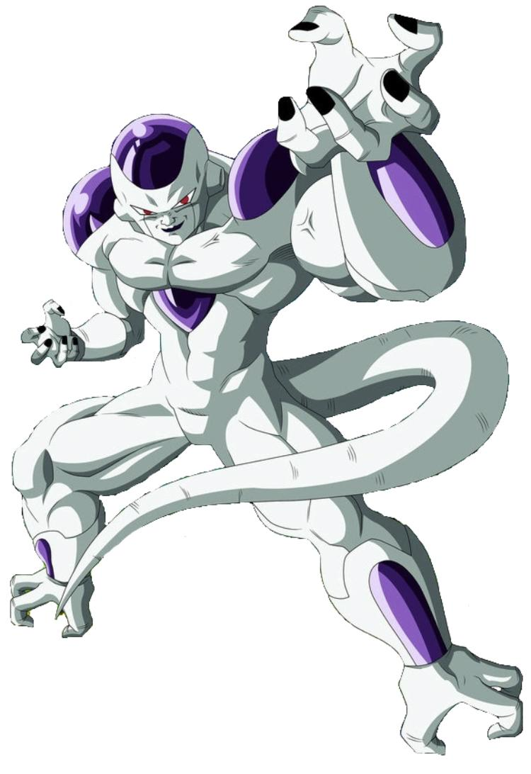

You can now reach your maximum power which, while mostly the same as your True Form, causes all of your muscle mass to increase greatly making your body become broader and your build become engorged compared to your base form’s sleek frame. While in this form you will have full access to 100% of your capabilities but your stamina will quickly drain. While in this form you have complete access to all of your power of 2,265 PL unless you are stronger in which case it will rise to match your Power Level. With training and practice the drain on your stamina will lessen to the point that you can stay in this form perpetually. The more control you gain the smaller your appearance will become as your muscles compress without any loss in power. With full control, you will look identical to your True Form and suffer no stamina drain.

***Almost Freeza Day Booster: Seasonal Mutant***

Though you don’t have a shiny nose you do have a mutation of your own. While normally this mutation would give you an evil nature and sadistic personality you don’t have that restriction. With this mutation, you can grow in power at an alarming rate over a short time. You will quickly outpace any training you do as your strength and speed grow continuously, requiring you to increase the intensity to match your current strength.

***Almost Freeza Day Booster: Ultimate Holiday (Requires “The Last Freeza Hero”, “The Freeza Day Star” and “Shining Freeza Day”)***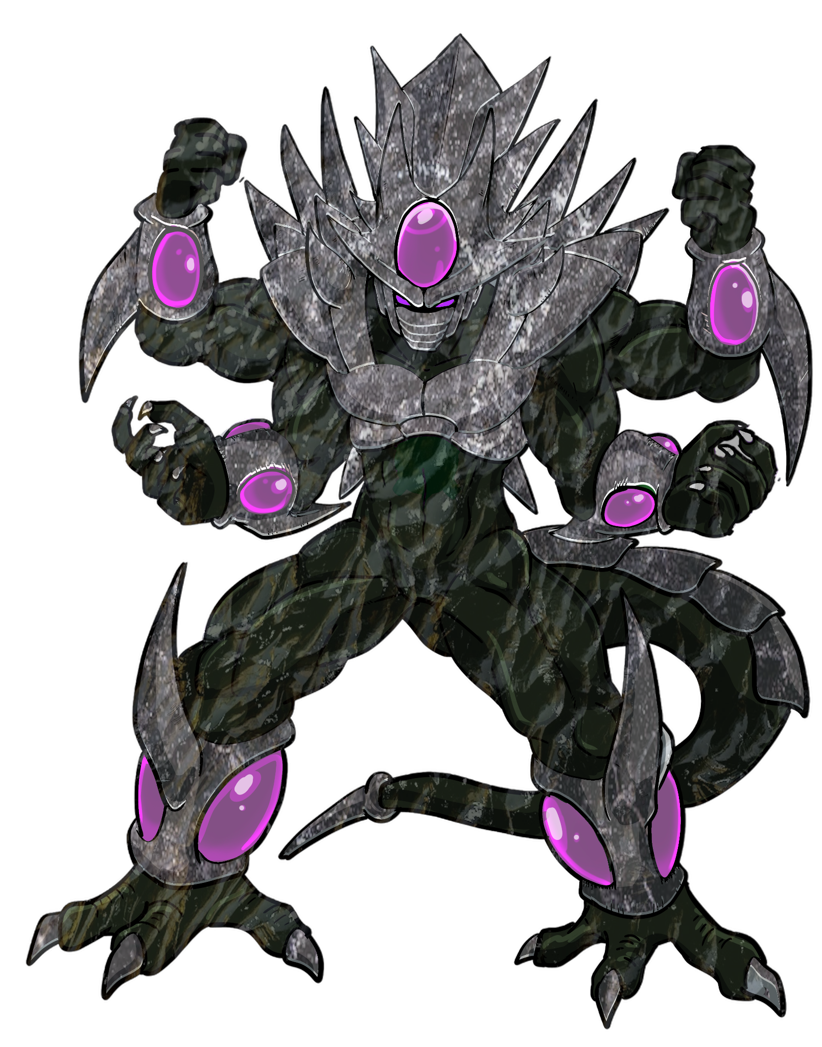

You can now combine all of your transformations, allowing you to become living liquid metal. While in this form all forms of power you possess are dramatically boosted with them passively growing in power to match your needs. In this form, you adapt to any form of harm, hazard, or damage that could affect you on a meta-narrative level. Mechanically this functions as the ultimate plot armor so that you gain resistance to anything that could destroy, weaken, or change you in any way you don't want. Should you be “permanently” defeated, disposed of, erased, or removed from reality you will be restored as if nothing happened.

**Armored Perk Tree:**

**Lethal Zarbon -100 CP (Free for Armored)**

You know how to get others to pump up effectively. With this perk any muscle or physical strength training you coach others on will be ten times as effective.

***Freeza All The Way Booster: Lethal Zarbon 2 The moan is back***

You can now teach others how to obtain a buff transformation that allows them to look more muscular while increasing their physical strength and durability.

**The Freeza Express -200 CP (Discounted for Armored)**

Your brain is one of your strongest muscles. Literally as you can now express psychic abilities, primarily psychokinesis with the same level of physical strength as your own body.

**HIFL Hard -400 CP (Discounted for Armored)**

With this perk, you feel an almost magnetic pull towards any action-oriented event, letting you choose to insert yourself into it in a narratively appropriate way.

***Almost Freeza Day Booster: HIFL Hard With a Vengeance***

Once per jump or once every ten years, whichever comes first, you will gain a 1-UP that will prevent your death and protect you with plot armor forcing you to escape with it remaining active until you have reached a location where you are safe.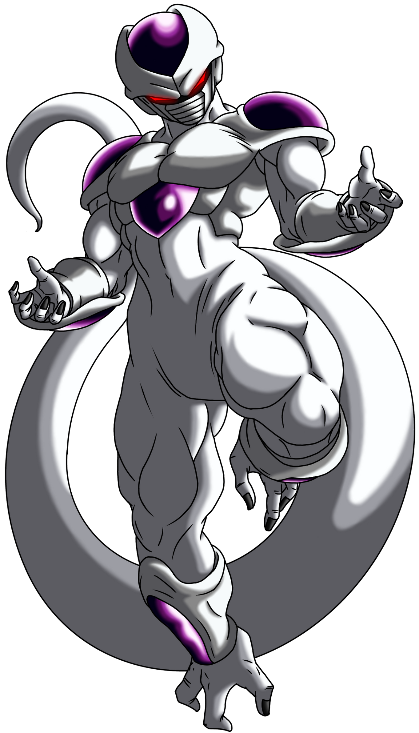

**Freeza All The Way -600 CP (Discounted for Armored, Requires “Form Sweet Form Alone”)**

You can now ascend your True Form into an Armoured Form that increases your power substantially. This transformation is an inversion of the standard transformations which simply suppress the user's true power. Instead, this greatly boosts the physical strength and durability of the user to 7,230% of your Base form while also enhancing your ki reserves to 150%. When taking on this form you become noticeably taller in addition to being far more muscular, your Bio-Suit gains shoulder bows, a helmet or crown-like armor around your head, back spikes, a facemask that hides your facial features, and potentially other features such as a stinger on your tail or additional spikes. Your minimum power level in this form would be 163,759 PL.

***Freeza Day All Over Again Booster: The 6th Freeza Day***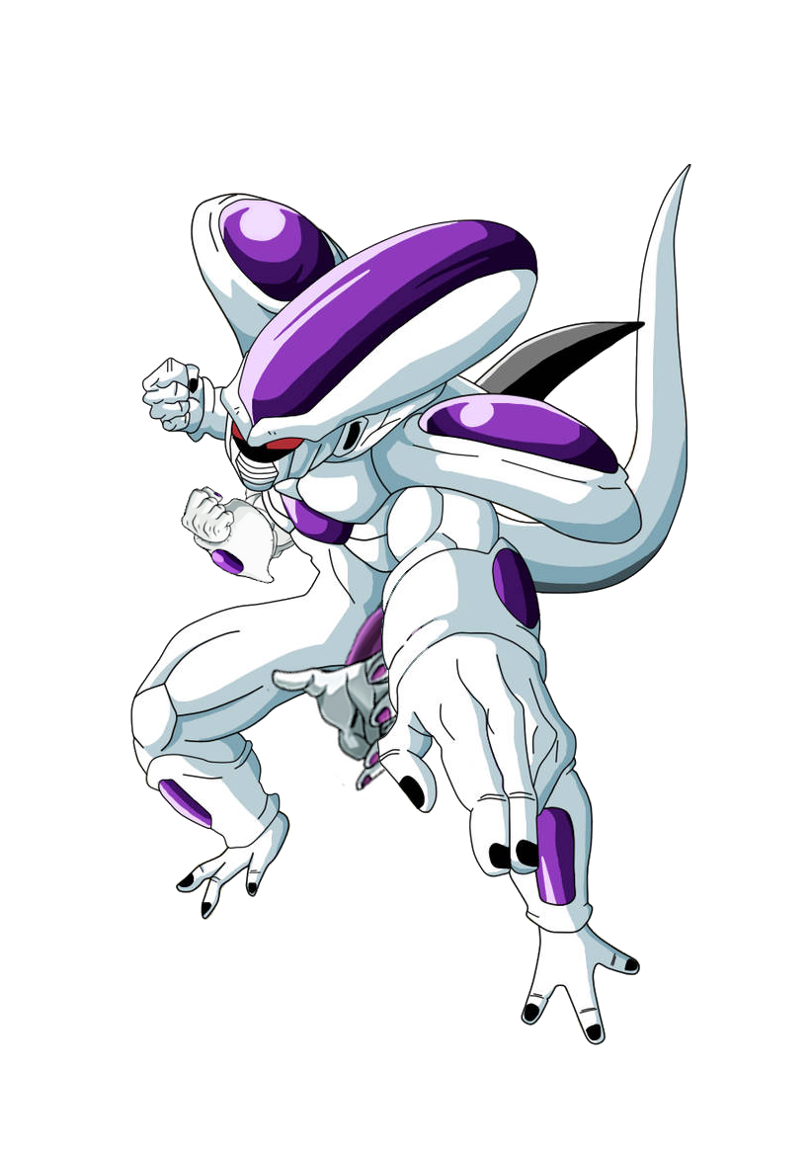

You can now transform even further from your Armoured Form into a Titan Form which increases your power even further. This transformation massively boosts the physical strength and durability of the user to 38,462% while also enhancing their ki reserves to 1,800%. When taking on this form you become even larger than your armored form with your cranium extending immensely and you gain a second set of arms that you can utilize in combat. You may also gain additional features such as multiple sets of horns, your claws becoming longer, your tail tip becoming very sharp, and additional exoskeleton plates. Your minimum power level in this form would be 871,164 PL

***The Freeza Express Booster: The Last Freeza Hero***

Why stick to just physical strength when you can also enhance your mental powers? You can now activate a reinforced transformation that you can stack on any other form, when activating this transformation your appearance changes, your exoskeleton takes on a darker colour, your gem plates take on a black tone and numerous horns appear on your head and shoulders. When transforming into this form your power level rises to 500% of your previous form, you are also able to create a mental connection with your opponent or opponents to read their surface thoughts, put them into a mental simulation without their knowing and your psychokinetic prowess can exert ten times your current physical strength. If used on top of your 100% form your minimum power level in this form would be 11,325 PL, if used with your Armoured Form your minimum power level would be 818,795 PL and if used with your Titan Form your minimum power level would be 4,355,820 PL 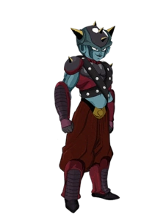

## **Metal Perk Tree:**

**The Freeza Day Candle -100 CP (Free for Metal)**

You are not only a brilliant scientist but an amazing teacher, when you are explaining academic knowledge to others they will better understand and retain the information allowing them to effectively utilize it.

***The Heart of Freeza Day Booster: Burning Cold at Both Ends***

You can now infect others with your nanites, which will have the nanites processed to restore the target's health and well-being. During the period of time the nanites are active they will replace any damaged or missing body parts with technological equivalents that their body won’t reject. These technological body parts can be replaced over time by the target's natural regenerative capabilities as they replace the added tissue with their natural equivalent.

**Journey to Namek -200 CP (Discounted for Metal)**

Whenever there is an event or object of interest that is about to become directly or indirectly relevant to you a sign of some kind will arise and catch your interest, such as a star leading to a stable or insubordinate monkeys talking about wishing orbs. When one of these events takes place you will always recognize the sign but not necessarily what the goal is you're looking for.

**Freeza Day Eve Vigil -400 CP (Discounted for Metal)**

You can grant yourself and others a short-term power up which multiplies power levels by burning through lifeforce. This power-up multiplies the user's strength, durability, speed, and ki but at the cost of rapidly aging them. While it is active their aura will take on a lilac and white colour but the higher the multiplier used the faster the target will age.

***Almost Freeza Day Booster: Freeza Day Grace***

You can now grant yourself and others an altered variant of this power-up with a lilac and black aura that painlessly burns through the body in exchange for power. While this power-up is active the user will be able to select what aspect of themselves they wish to empower and where to focus the burn, with the body parts literally burning to ash as they gain the power boost. The higher the power multiplier and the wider the scope of the power up the faster it burns.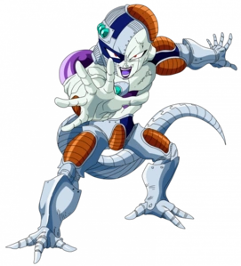

**The Heart of Freeza Day -600 CP (Discounted for Metal, Requires “Form Sweet Form Alone”)**

Your Bio-Suit now has nanite-based technology integrated into it that boosts the power level of each of your forms by 20%. These nanites also enhance your physical durability and energy reserves by 150%. Your cells will produce these nanites naturally and if you lose a proportional amount of your bio-mass the nanites will create a cybernetic equivalent and help your body regrow the biomass with the cybernetics acting as a framework. The nanites can also shield you from most forms of ki-sense and life force sensors.

***Freeza Day All Over Again Booster: Sharing Freeza Day***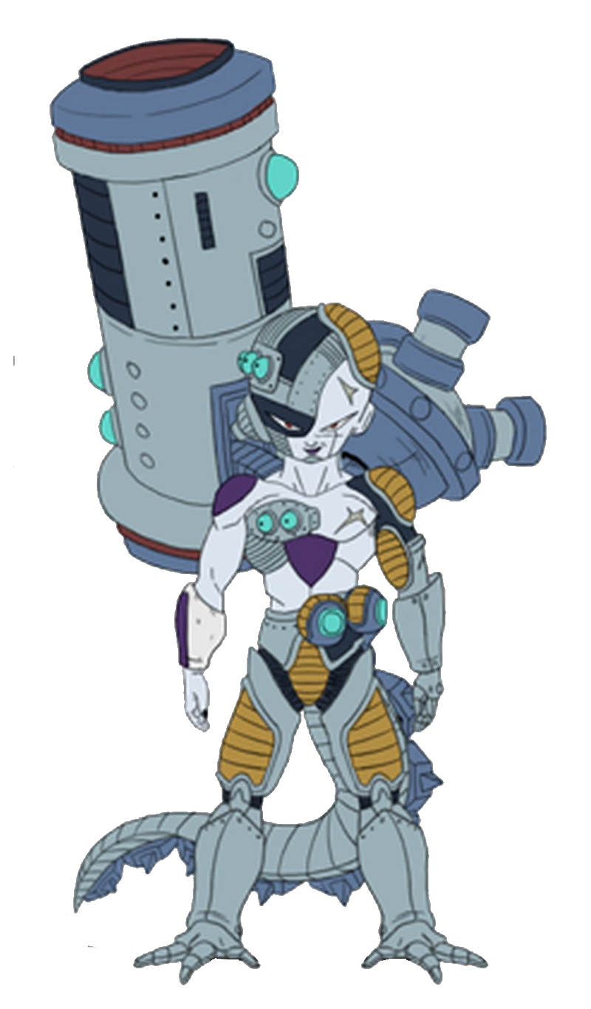

Your nanites are now far more advanced allowing you to integrate, optimize and replicate technology. When gaining this upgrade the power level of each of your forms is increased by an additional 30%, and your physical durability increases by an extra 80%. Whenever you come into physical contact with technology you can spread your nanites to either have them take direct control of the device or break it down for absorption. Any technology or parts that your nanites integrate with are copied as blueprints that your nanites can reform, replicating the device and giving you an intimate knowledge of the technology. When taking control of technology your nanites can utilize any blueprints they possess to upgrade the device making it more advanced or causing new features to form. By default, you will have the blueprints for several energy-enhancing weapons allowing you to manifest an energy cannon that will enhance the power of any energy blast you fire from it, chargeable grenade-like tools that will produce wide area energy explosions and your can produce additional armor blades that can channel Ki to produce energy blades.

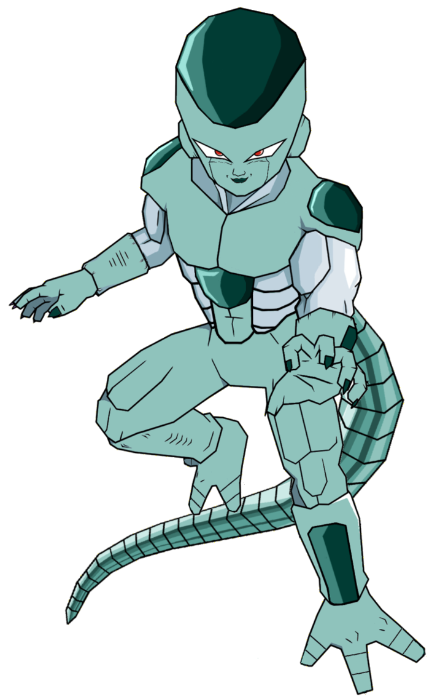

***Journey to Namek Booster: The Freeza Day Star***

It seems you have found your own Star! That is your own Big Gete Star. From this, each of your forms are boosted by 100% with the nanites also enhancing your physical durability and energy reserves by 400%. Your nanites can also be spread out separately from your body as drones that will automatically seek out anything of interest to you and keep you up to date on its progress. Any of your nanites including your drones can be programmed to create full mechanical copies of yourself, facilities, and transportation systems for anything you take interest in. You can instinctively control any of your nanites in several ways including commanding selections of nanites, remotely taking full control of specific nanites, or giving orders that the selected nanites will follow. The nanites within your body also gain an upgrade for their regenerative capabilities allowing them to regrow your bio-mass within seconds of the technological equivalent forming.

## **Gold Perk Tree:**

**The Subordinate’s Freeza Carol -100 CP (Free for Gold)**

You can now teach others how to better harmonize, making any teaching you do in regards to song, dance, or energy movement such as Ki or Magic become far more effective. This allows you to easily set up an amazing musical number on short notice and show others how to perform energy techniques.

***A Golden Freeza Day Booster: The Subordinate’s Treasure Island***

Like the search for buried treasure those who follow you will find the real gold was within them all along. Well, at least it is now, with this perk you can help others unlock a golden form that will enhance the power of their energy without necessarily increasing their reserves. When transformed they will gain some form of golden colouring depending on their species whether this is golden hair, golden skin, golden plating, golden markings, or just a golden aura.

**All I Want for Freeza Day -200 CP (Discounted for Gold)**

Whenever you need to get someone a gift you can choose to gain the knowledge of what they want most and how to get it for them. If this is too much for you, you can instead target a potential present with who you have in mind and see how they would react to getting it. An interesting side effect is it will also show you how negatively they might react to allowing you to see if they would be afraid of, insulted, or disgusted by getting that gift.

**The Freeza Clause -400 CP (Discounted for Gold)**

You can target individuals or set up an area of effect where any lies they attempt to speak will come out as unintentional truth. While they are speaking they will believe they are saying whatever they intended to say but will instead be saying the full truth without any deceptions. When the effect is removed the speaker will realise what they have actually said.

***Almost Freeza Day Booster:* The Freeza Clause *2 ½: The Smell of Fear***

You can now understand the truth of a situation to see what actions are real and what are intended to deceive. From this, you can hear the words someone is saying to you while mentally understanding the full truth of the situation as the person knows it to be without any other party knowing what you are learning.

**A Golden Freeza Day -600 CP (Discounted for Gold, Requires “Form Sweet Form Alone”)**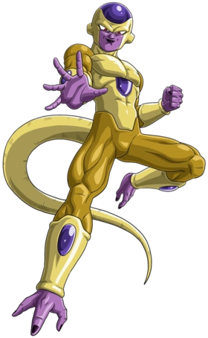

You can utilize your energy to boost your Ki power immensely allowing you to transform into a golden form that boosts the power of your Ki usage including Energy Enhancements and Energy Projectiles by 200,000% of your current form. However, the overwhelming power gained from this form comes at a great cost, the form is very taxing on the user's stamina which causes their power to drop the longer they are in the form, resulting in them losing approximately 0.1% of their total power level every second. By default, this form is Golden in colour but when purchasing it you could instead choose another metallic or gemstone colour for the form to take such as silver, opal, or jade.

***Freeza Day All Over Again Booster: Black Freeza Day***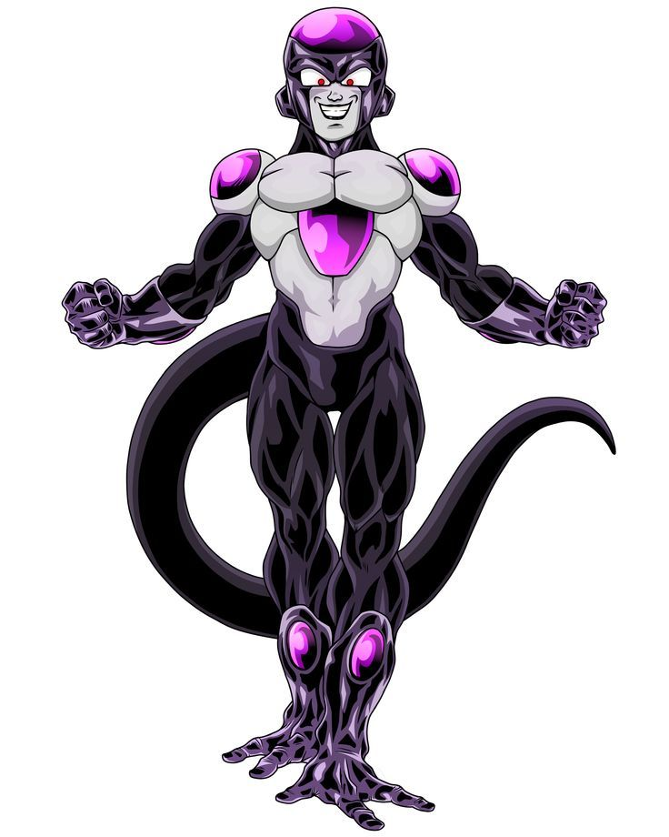

You have reached a new stage of power as you can now enhance your golden transformation into your ~~Black~~ Obsidian form. This transformation makes most of your bio-suit black and allows you to reinforce every strike with efficient Ki boosting the power of your Ki usage including Energy Enhancements and Energy Projectiles by a thousandfold of your golden form giving you a 200,000,000% boost. While in this form each strike you make utilizes as much Ki as it needs to perform the desired result so that if you wish to harm but not kill the strike will have the exact amount of Ki you require but if you want to punch all the way through them your strike will have the exact amount of ki you need. However, unless you have found a way around it you will still be losing stamina in this form and your power level will be dropping faster the more you fight.



***All I Want for Freeza Day Booster: Shining Freeza Day***

You have found a way to fulfill the wishes and needs of yourself and others through indirect means. Firstly you will no longer suffer the weakness of your Golden or ~~Black~~ Obsidian Forms as this form is now stable and will not leak stamina but your form will become a uniform shining colour. That’s not all though as while in this form you can in a way fulfill the desires of others as you can expend a proportional amount of energy to grant the target’s heartfelt desires. This form of desire fulfillment is not the true art of miracles and may have unpleasant consequences.

# **Presents:**

It’s time for the most enjoyable time of the season, the presents.

Any lost or stolen presents will return to you after a week in the same condition as when you had them. Any damaged items could potentially be repaired if worked on by a capable engineer.

**Free Gift - Free**

You may only take this gift once and must roll a **D20** you will then gain the corresponding present for **Free** wrapped up in a gift box.

**Freeza Force Armor - Free**

This Battle Armor is a standard-issue combat attire currently mandatory throughout the Freeza Force. This armor is very durable, yet also flexible and stretchy, easily conforming to the movements and size-changing transformations of its wearer without losing its original shape.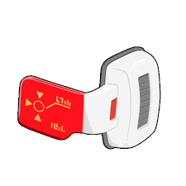

**Freeza Force Scouter - Free**

A Scouter is a wearable, all-purpose computer that Freeza's army uses to measure power levels. A trained person is capable of consciously lowering their ki to fool scouter to show a lower power level and when reading a higher power level than its maximum limit they explode.

**Freeza Day Story Book -50 CP**

This item is **Free Gift** Roll **1**.

This thick leather bond storybook contains many Freeza Day classics including “A Freeza Day Demand”, “A Visit from King Cold”, “The Planet Cracker and The Monkey King”, “A Freeza Day in HIFL” and let’s not forget the beloved classic “How Cooler Stole Freeza Day”.

**Soul Scrubber Residue -50 CP**

This item is **Free Gift** Roll **2**.

The glistening white remnant of shattered souls rich in sin and evil. It’s the perfect gift for sin-eaters and those who wish to make armies of screaming snowmen.

**Box of Stuff -50 CP**

This item is **Free Gift** Roll **3**.

A cardboard box that you can store an infinite amount of stuff in and withdraw any of it at will without increasing the weight of the box.

**Claymation Set -50 CP**

This item is **Free Gift** Roll **4**.

A set of claymation dolls and toys comes with a complete Plasticine kit, including a tabletop set, scene props, full instructions, a fold-out scene, 3D accessories, extra card props, Plasticine modeling clay, foam pieces and props, Non-drying and self-refilling pot of reusable paint for you to start filming your own Freeza adventures

**Present Boxes -50 CP**

This item is **Free Gift** Roll **5**.

This Box contains an infinite supply of empty present boxes that can grow and shrink to match whatever present you wish to put inside it.

**Spacy’s Gift Card -50 CP**

This item is **Free Gift** Roll **6**.

This gift card can be used at any restaurant or establishment that sells food. This card tops up with enough currency to buy any meal on the menu whenever you attempt to use it, allowing you to eat for free anywhere.

**Crack Bomb -50 CP**

This item is **Free Gift** Roll **7**.

This small explosive missile can be launched from any form of explosive and has the same amount of power as a blast fired with a Power Level of 530,000 PL however you can charge it with ki to increase its power.

**Grenades -50 CP**

This item is **Free Gift** Roll **8**.

These powerful grenades are incapable of harming you but contain the same explosive power as a blast fired with a Power Level of 530,000 PL however you can charge it with ki to increase its power.

**Rocket Launcher -100 CP**

This item is **Free Gift** Roll **9**.

This specialized weapon allows its user to launch Ki blasts, missiles, grenades, mines as well as any form of projectile the user inserts into it all of which are enhanced by both the weapons launching system and the user's Ki.

**Freeza's Hover Pod -200 CP**

This item is **Free Gift** Roll **10**.

This floating, egg-shaped vehicle was used by Freeza as a means of transportation. This hover pod is a comfortable means of getting around not only due to its soft internal furnishing but also because of its internal atmosphere controls that allow it to make the inside of the pod the exact temperature and chemical composition that is the most comfortable for your species.

**Senzu Beans -200 CP**

This item is **Free Gift** Roll **11**.

This self-refilling pouch contains 10 green beans that are restocked once per day. When one of these beans is eaten it will heal the consumer's wounds, recover any stamina or energy they have lost, and make them feel full without needing to eat or drink for a week.

**Micro Watch -300 CP**

This item is **Free Gift** Roll **12**.

This unbreakable watch has an unlimited power supply that allows it to not only tell the time accurately for any location (including your current location) but also allows you to shrink yourself and anything you are holding to a smaller size almost instantly. This can range from just a bit shorter to almost too small to be seen with the human eye. While you are shrunk you become proportionally weaker to your decrease in size.

**Super Scouter -300 CP**

This item is **Free Gift** Roll **13**.

This upgraded scouter comes with a mimicry recording feature that allows it to record the biological abilities, skills, and techniques of others for future use. If you record someone regrowing a limb or healing someone through magic or other means to regrow a limb you may use the recordings later to regrow a limb of your own at the cost of losing the recording.

**Death Bomb -300 CP**

This item is **Free Gift** Roll **14**.

This highly efficient explosive can be used on any building to make it perfectly explode so that the rubble lands in a perfectly tidy pile and the land the building was on is perfectly flat.

When used in a gauntlet this item will function as though fiat-backed to your bodymod but you will only have access to 1 before the jump or gauntlet ends.

**Freeza's Spaceship -400 CP**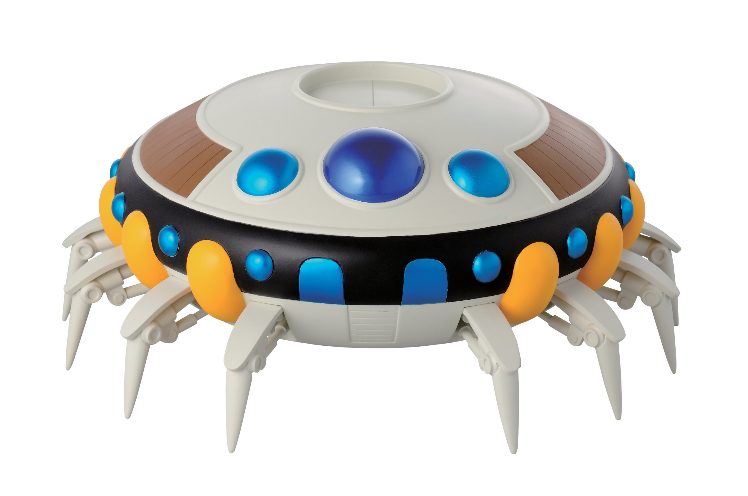

This item is **Free Gift** Roll **15**.

This large, round ship previously owned by Freeza can be used for means of interplanetary travel and base of operations. The ship does not move through jet propulsion, its entire bottom section is an anti-gravitational device that allows it to move through gravity control. In addition to Freeza's personal room, the ship has a command center, two Medical Machine tanks (one new and one old), many wall-mounted crew beds, and a locker room.

**Metamo-Ring Set -400 CP**

This item is **Free Gift** Roll **16**.

These two rings are actually super advanced technology that allows any two people wearing them to fuse into the same person for as long as they wish. The fusion can defuse at will by removing the single Metamo-Ring created when the two Metamo-Rings fuse as part of the fusion.

**Ensenji -400 CP**

This item is **Free Gift** Roll **17**.

Once per day you gain a delicious fruit that is similar to a golden peach and has restorative effects that can heal the consumer's wounds, extend their lifespan by five percent, fill them for three years so that they no longer need food or drink, and if they have never eaten an Ensenji before it will double their strength, durability, and energy, doubling their power level.

**Fruit of the Tree of Might -400 CP**

This item is **Free Gift** Roll **18**.

Once per day you gain a divine fruit that comes from the Tree of Might. The fruit multiplies the power of anyone who consumes it by 15, though is normally reserved for deities.

**Eternal Energy Reactor -500 CP**

This item is **Free Gift** Roll **19**.

You gain not only this device but also its blueprints. This device is similar to a high-powered battery that constantly generates energy to refill its charge. If the Eternal Energy is able to power any technology it is connected to preventing it from ever running out of power but cannot boost the total output of whatever it is powering. If the Eternal Energy is integrated into a living being they will have infinite stamina.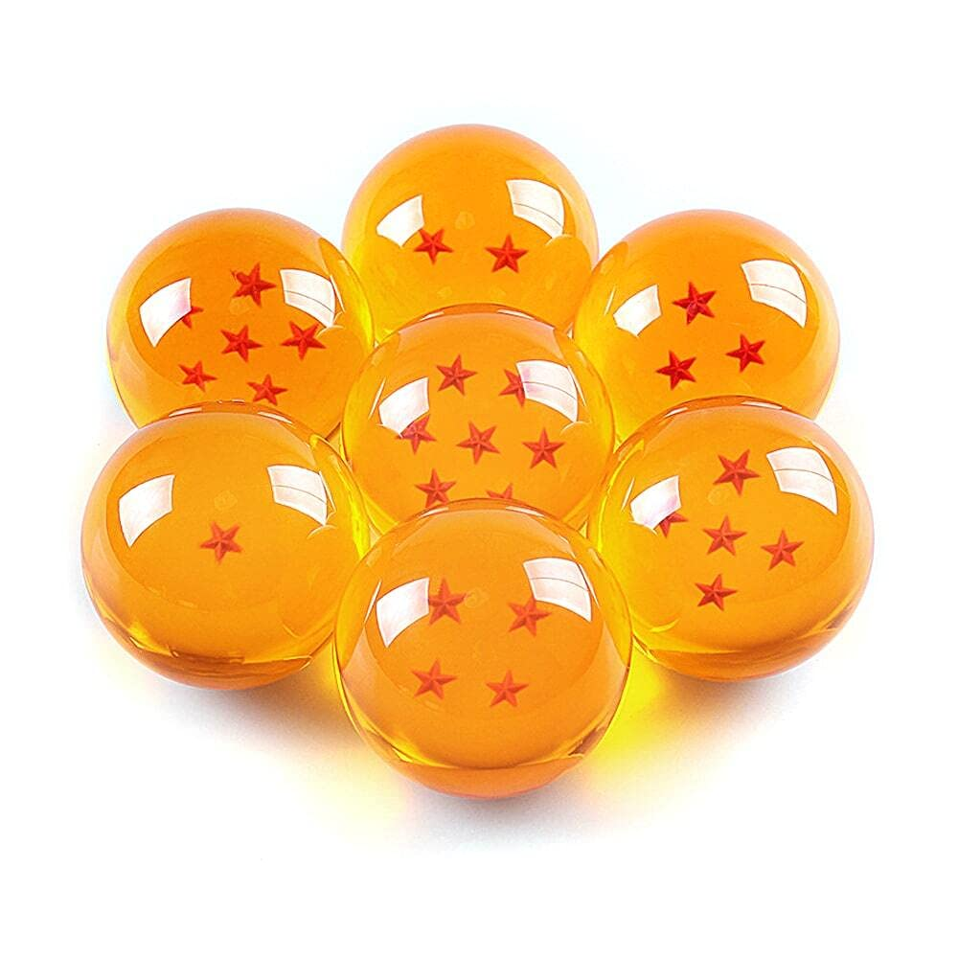

**Dragon Balls -1000 CP**

This item is **Free Gift** Roll **20**.

You have managed to get your hands on a complete set of seven Dragon Balls which once per jump or once per ten years will summon an Eternal Dragon. When summoned the Eternal Dragon will grant you any one Wish so long as it is possible within the current jump setting. Unlike a normal set of Dragon Balls, when a wish is granted these Dragon Balls will remain in place but lose their stars until they are ready to be used again.

# **Drawbacks:**

**Seasons Beatings +200 CP**

Normally you would be the only celebrator of Freeza Day within this continuity, however with this drawback a squad of Freeza Force soldiers will appear in this continuity.

**Stay in Your Lane +300 CP**

You can only purchase **General Perks** and Perk’s from your selected **Origin Perk Tree**.

**Holiday Fanatic +400 CP**

You are no longer a Drop-In or from an alternate Reality.

You are instead Local who somehow heard of the Holiday season.

You will need to work out your Background with your Jump Chan but you will no longer be a member of the Freeza Race and will lose all presents from this Supplement other than your **Free Gift**.

**Such Beautiful Fireworks +500 CP**

Should a good enough gift not be given to Freeza each year your planet will be blown up.

**Jacked Frost +200/400 CP**

Universe 6 has been hitting the gym as the space pirate Frost has unlocked his fifth armored form.

For **+200 CP** he gained all the Free **General Perks** and all Perks in the **Armoured** Perk Tree.

For **+400 CP** he has also unlocked the perk **Freeza Day All Over Again**.

**Baby, It’s Cold Outside +200/400 CP**

It seems that the great King Cold has come across a bit of a parasite problem as he has been infected by the Baby Parasite who sees him as the ultimate body.

For **+200 CP** he gained all the Free **General Perks** and all Perks in the **Metal** Perk Tree.

For **+400 CP** he has also unlocked the perk **Freeza Day All Over Again**.

**The Chilledness before Freeza Day +200/400 CP**

Lord Chilled the lord of Wrestling Wednesdays has returned in an all-new golden leotard.

For **+200 CP** he gained all the Free **General Perks** and all Perks in the **Gold** Perk Tree.

For **+400 CP** he has also unlocked the perk **Freeza Day All Over Again**.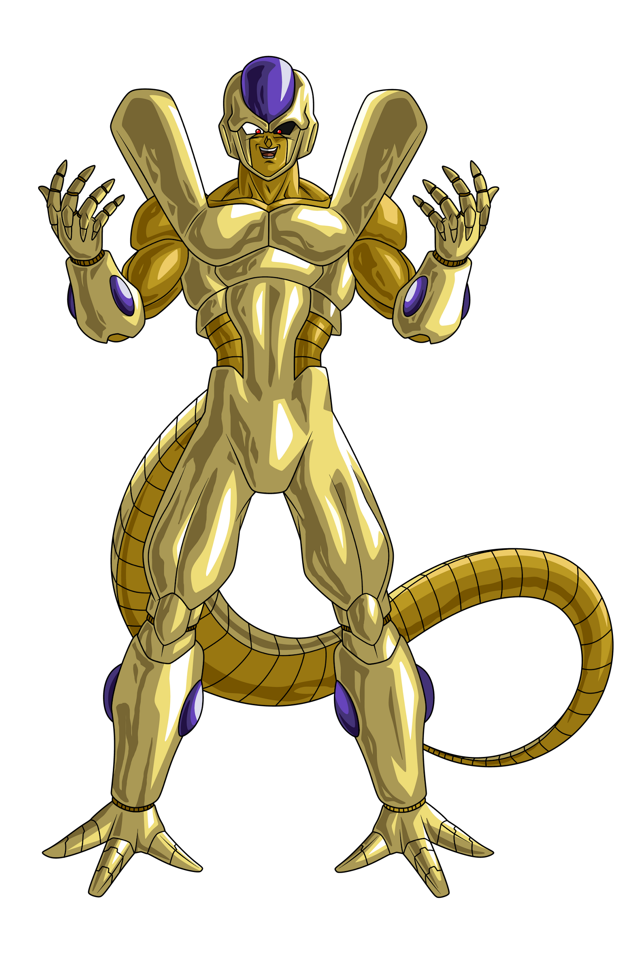

**You’re a Mean One Monsieur Cooler +600/1200 CP**

The Lord whose power level grows three sizes Lord Cooler has arrived.

For **+600 CP** Cooler will appear with all the perks in this Jumpchain.

For **+1200 CP** Coolers Subordinates Salza, Dore, and Neiz will each have all the General Perks but will be unable to access the Freeza Race Alt-Form however they will each have all the perks of a corresponding Origin Perk Tree. Salza will have all the Gold Origin Perks, Dore will have all the Armoured Origin Perks and Neiz will have all the Metal Origin Perks.

## **Generic Drawbacks:**

**Accident Prone​ +100 CP**

You’re prone to minor accidents that, while inconvenient, painful, or embarrassing, are not likely to kill you. You can expect any plans you make to suffer some kind of bad luck.

**Acrophobic +100 CP**

You are terrified of heights, and anything deeper than a 10-foot drop will make you weak in the knees.

**Age Problems +100 CP**

For the duration of this Jump, you lose all age resistance perks and powers.

**Almost Entirely Dark +100 CP**

Has the sun gone out or something? Everywhere you go, it seems like it’s so dark that you could mistake midday for early night.

**Always Left Behind +100 CP**

Why do they keep leaving you behind?! You will find that Companions, allies, and benefactors are always ditching you to deal with things unrelated to your current predicament.

**Amnesia; Jumpdoc +100 CP**

You lose all memories and knowledge of what you purchased in this Out of Context Supplement and any connected Jumpchain.

**Angered Factions +100 CP**

Each time you take this, a different, random local faction will consider you an enemy once they become aware of you. There isn’t a limit to how many times this may be taken.

**Antagonistic Timing +100 CP**

Your enemies keep showing up at inappropriate times.

**Artificial Flashbacks +100 CP**

You have horrific flashbacks to horrible events involving your family and yourself. These events never actually took place, and the flashbacks happen randomly.

**As You Know +100 CP**

Everyone expects you to already know what’s going on, so don’t expect to get any explanations.

**At Least Buy Me Dinner First +100 CP**

Dangerous entities have a habit of taking an interest in you… a romantic interest.

**Awkward Affection +100 CP**

You are really bad at expressing your affection. Every attempt you make is extremely awkward and unpleasant for anyone who observes it.

**Bad Name +100 CP**

Everyone you meet will assume your name is something that you find insulting or annoying, and nothing you can do will change it in your mind.

**Behind Your Back +100 CP**

People always say horrible, hurtful things about you whenever they *think* you're out of earshot.

**Black Cat +100 CP**

Expect to see ill omens that seem to suggest terrible things coming your way. Mirrors break in your presence, lone magpies drop-dead at your feet, and other strange, malign portents follow you. Let's hope these superstitions are just that.

**Bounty +100 CP**

It seems you’ve pissed off the wrong people. You have a notable bounty on your head, and while it’s not enough to get the big guys interested, it *is* enough to draw the attention of random thugs.

**Culture Shock +100 CP**

This world doesn’t have the same cultural standards you’re used to, which isn’t a problem if you’re quick to adapt. Unfortunately, you *won’t* be. You’ll constantly butt heads with anyone whose cultural norms and social mores are different from your own. While you can slowly adapt, they’ll always rub you the wrong way, and your overall experience here will be much less enjoyable.

**Crop Rotation +100 CP**

Pests and poor weather have had a serious impact on the local farming industry. Food will be harder to come across and far more expensive as a result.

**Dark Memories +100 CP**

You will now gain memories of a lifetime of abuse since early childhood. Though these memories are false, you will not be able to differentiate them from real memories beyond knowing they are fake.

**Didn’t Read The Instructions +100 CP**

You don’t know how anything works and refuse to have anything explained to you. Using any sort of equipment will require trial and error.

**Disinteresting +100 CP**

You seem to emit an aura of monotony, causing everyone who doesn’t know you to think you are a boring stick in the mud that wouldn’t know fun if it hit them.

**Do you Feel Lucky, Punk +100 CP**

You keep unintentionally making pop culture references that no one else seems to recognise.

**Double Trouble +100 CP**

You will always encounter twice as many enemies in the world, because every foe you face will have one identical copy that only you can see. The worst part is that this seems to be a Schrödinger situation, as the *real* one is never the one you defeat first.

**Easily Deceived +100 CP**

You’re too trusting, willing to believe almost anything you’re told, and become confused when you’re told conflicting things.

**Elites Everywhere +100 CP**

Every group of opponents that you face will have at least one additional elite member.

**Extended Stay +100 CP**

You can increase the duration of this Jump by ten years. You can take this a maximum of ten times, increasing it by up to one hundred additional years.

**Faulty Gear +100 CP**

Any tools you attempt to use will rust and decay at an accelerated rate, and you won’t realize how severe the damage is until it is too late to repair.

**Friend List +100 CP**

Random people claiming to be your friends keep showing up, but you won’t remember any of them. Although some of them may be, most are trying to maliciously use you for their own benefit.

**Friends to the Four Winds +100 CP**

Instead of arriving at your Location Choice, your Companions are now scattered randomly throughout the setting. They won’t be able to enter your Warehouse until they’ve found either you or one of your properties.

**The Glitch​ +100 CP**

Technology randomly fails around you, normally when you need it the most. You might be able to jury-rig a quick repair, but you'd better act quickly because while this won’t be instantly fatal, it will make things more dangerous.

**Gore Galore +100 CP**

It seems that every creature you kill has ten times the amount of blood and viscera that you would expect, making it a real possibility of drowning in the blood of your enemies.

**G-Rated +100 CP (Incompatible with “X-Rated”)**

This Jump is now a family feature... or so it seems when it comes to you. Any attempts to swear, drink alcohol, take recreational drugs, have sex, kill someone, or anything that might warrant a PG rating will be averted at the last moment – often painfully and humorously.

**Heroic Sayings +100 CP**

You have several quotes and sayings that always come across as annoying or cheesy, which you unintentionally use every time you try to talk to others.

**Hidden Knowledge +100 CP**

People keep forgetting to tell you important things until it’s *just* about to become relevant.

**Hideous Haircut +100 CP**

You have a haircut that everyone finds disgusting. They’ll make comments about how ugly it is, and nothing you do will change it.

**The Holiday Special +100 CP**

Whenever you reach an in-Jump holiday, the world around you will start to follow the tropes of a Special Holiday Episode. This will happen for every main holiday, such as Christmas or Halloween, and at least once during the Jump for each lesser-celebrated holiday like May Day or April Fools’ Day.

**Honorbound +100 CP**

You always do things as honorably as possible, such as informing someone if you intend to arrest (or kill) them before giving them time to surrender (or prepare) before taking action.

**How Do I Keep Falling Into These Situations? +100 CP**

Anytime you’re not busy with something - whenever you aimlessly wander around, going for a jog, or you just have free time - you’ll find yourself walking right into the middle of active trouble.

**I Must Nap +100 CP**

You need at least seven hours of sleep per day, or you’ll feel exhausted.

**I Spy +100 CP**

Your enemies can easily spy on you without being detected.

**In Another Castle +100 CP**

Each time you attempt to complete a task or objective, you will find that you have been tricked and will have to repeat the process all over again. You’ll not only forget this Drawback, you’ll also forget every previous time you’ve been affected by it whenever you start a different task. This only triggers once per task and will not become an endless loop of deception.

**Inconveniences +100 CP**

You will constantly encounter minor obstacles that are uncomfortable to deal with.

**Kick The Cook +100 CP**

You are a terrible chef and everything you cook is disgusting. You can't even cook toast without making it *monstrously* vile.

**Knowledge Lockout +100 CP**

You lose all of your knowledge of the setting’s universe and its continuities once you start the Jump.

**Language Barrier +100 CP**

You do not speak the local language, and no one here knows what you're saying until you learn.

**Loser +100 CP**

Anyone who doesn’t know you will automatically expect you to fail at whatever you are

trying to do. This will cause those who mean well to push you to work harder and those who

don’t mean well to attempt to discredit you.

**Low Budget +100 CP**

Something about this world just seems... *cheap*, with flying wires, plastic shields, old school lights, and tatty-looking monsters.

**Magnet For Misfortune +100 CP**

You have *terrible* luck. You’re almost constantly hit by random, unpleasant, and painful bouts of misfortune.

**Money Money Money +100 CP**

Your avaricious desire for money and other symbols of wealth leaves you willing to go to extreme lengths to get more.

**Never Mind My Head Trauma +100 CP**

People don't care when you’re injured.

**Nightmare +100 CP**

Every night, you’ll fall asleep and suffer terrible dreams.

**No Hard Feelings +100 CP**

There’s one random person who constantly tries to outdo you… And somehow, they keep succeeding before rubbing it in your face.

**Optician Required +100 CP**

Your eyesight is highly restricted, as you can not see anything other than indistinct blurs without wearing glasses. No form of healing can remove this drawback, and any form of contact lens will feel incredibly itchy.

**Orphan +100 CP**

Your in-universe parents are dead, and you are an orphan.

**Pixelated Objects +100 CP**

This pixelation in this Jump would shame an NES. Everything is blocky!

**Plot Anchor +100 CP**

Every plot seems to revolve around you, and no matter what you do, you will always be dragged into the story.

**The Pollen +100 CP**

You have hay fever, and it’s really, *really* bad. Just a handful of flowers could leave you with blurred vision and sneezing for hours.

**Prove Your Worth +100 CP**

Every time you try to do anything, it seems that everyone wants you to complete an arbitrary task to somehow prove your worthiness. This won’t be hard, but it happens all the time for even the smallest things. It may even cause you to get stuck in a worthiness spiral, requiring you to prove your worth to get things needed to prove your worth for some totally unrelated task.

**Recurring Foe +100 CP**

You have an enemy whom you have no way to convince to leave you alone. Each time they encounter you, they learn more about you and how to better face you in the future.

**Rough Childhood +100 CP**

You were not as lucky as some people. Your in-universe childhood was - or will be - abusive and painful to such a degree that you will be affected by it, even if you didn't really live through it.

Gain an extra **+100 CP** if taken with **Just A Child**.

**Scarred +100 CP**

You either have horrible burns or horrible wounds, neither of which you can hide. You appear monstrous to others, causing most to feel deep fear at the sight of you.

**Scripted Encounters​ +100 CP**

You’ll run into whatever threat you’re dealing with more often. You won’t automatically become a priority target, but sheer proximity is likely to put you at risk.

**Shameful Attraction +100 CP**

The worst kind of perverts keep seeking you out and trying to get you to fulfill their fetish.

**Shy +100 CP**

You find that it’s incredibly difficult to talk with people you want to be friends with.

**Sickly +100 CP**

You have a poor immune system and are more susceptible to illness. You’ll get sick at least once a month.

**Silent Night +100 CP**

Unfortunately not. An annoying narrator who constantly insults you and reiterates things that you already know will rhyme in your inner ear every. Single. Christmas.

**Silent World +100 CP**

The world seems emptier than it ought to be. You don't know what happened, but the population of your starting planet (or nearest equivalent) is *drastically* lower than expected. After including every named character, the population is at most **10%** of its expected total. If you would normally see eight billion humans, you can instead expect to see as few as eight *million* instead.

**Simple Minded +100 CP**

You find it difficult to understand somewhat complex topics, and you have trouble remembering when holidays are.

**Stalker +100 CP**

A random, ordinary human knows *everything* about you and is *obsessed* with you. They’re also protected from any Perks or Powers that would help you find them quickly.

**Stranded +100 CP**

Instead of whatever your normal starting location would have been, you find yourself in the middle of a deserted island somewhere in an ocean.

**Team Up +100 CP**

It seems that you can't go anywhere without some random person showing up and joining you. What's worse, *they* always seem to get any of the praise you may have earned, and *you* always get all the criticism for the group’s failures.

**They Heard You +100 CP**

Any time you say something mean about someone, they’ll overhear you and probably get upset. You will forget you took this Drawback.

**They Took My Loot! +100 CP**

Any time you leave any treasure unguarded, expect thieves to show up and steal it.

**This Is A Holdup +100 CP**

For some reason, every two-bit henchman, sidekick, minor minion, and comedy relief character thinks they can kick your ass, and they’re going to go out of their way to prove it! Expect to get mugged *a lot*.

**This Is A Really Good Book +100 CP**

Whenever you try to read a book, you get sucked into the narrative and ignore everything happening around you.

**Thugs For Days +100 CP**

Every day, a minimum of ten random thugs will show up and target you.

**Touch Of Madness +100 CP**

Things keep happening that leave you thinking you’re going crazy… and maybe you are, but not because of this Drawback.

**Turn-Based +100 CP**

Whenever you enter into a fight with someone, you will find yourself transported into a weird pocket dimension where you are only able to take an action after each of your opponents in a fight.

**Two Of A Kind +100 CP**

People keep drawing parallels between you and other people, and these comparisons are *not* flattering.

**Unknown Rival +100 CP**

It appears someone has taken a shine to you, but not in a good way. They have abilities or a similar area of expertise to you, and they’re *not* taking it well. They won’t do anything to outright harm you, but they *will* try to one-up or challenge you, and there’s not much you can do to get rid of them. If you beat them at their own game, they’ll double down. If you try to help them beat *you* to get them to leave you alone, you’ll come out on top purely by accident, which will, again, spur them to double down.

**Unnecessarily Slow +100 CP**

Everything that happens here seems to take forever, moving at a snail's pace. I hope you're a patient person.

**Unwanted Crossover +100 CP**

This drawback acts like a magnet for other settings, resulting in strange individuals from other worlds popping up and potentially causing us issues. These individuals tend to have power consistent with the power level of the chosen setting, but you won’t have any way of knowing when someone new has shown up.

**Wanted +100 CP**

You have a criminal record somewhere out there. It has a surprisingly high bounty, but not so much that you will be sought out. People *probably* won’t go after you as long as you stay away from wherever your wanted poster is.

**Wearing Underwear on the Outside +100 CP**

You have terrible dress sense, with everything you wear being the worst possible combination of clothing.

**The Weirdo +100 CP**

Everyone seems to think that you are a strange individual, and they will go out of their way to avoid you unless they actually need to speak to you.

**What’s His Name? +100 CP**

No one seems to remember your name, so you’ve been given a nickname that really winds you up. What's worse, most people think that it’s your actual name.

**What's That Smell? +100 CP**

No matter where you go, no matter what you do, something always smells slightly off. The source of the smell varies depending on your location, but it’s always distracting.

**What’s Wrong With His Face? +100 CP**

Your face has been messed up, leaving you grotesquely ugly and near-unrecognizable to everyone who knows you. Those with a weak stomach may be sick merely at the sight of you.

**Where Did I Go Wrong? +100 CP**

You can’t tell the difference between confidence and arrogance.

**Why Am I Naked +100 CP**

You start this Jump naked, and your clothing becomes incredibly fragile as it keeps getting destroyed, leaving you in the nude.

**X-Rated +100 CP (Incompatible with “G-Rated”)**

Things in this Jump are a little more… *explicit* than normal. Sex, drugs, murder, and a lot more are out there, and it's almost like this world is desperate to show it all off.

**Amnesia; Local +200 CP**

Until the end of this Jump, you can not remember the events of the setting you have entered.

**Amnesia; Personal +200 CP**

You have no memories of your personal life before entering the current Jump, but this does not affect academic, social, or media knowledge.

**Amnesia; Jumper +200 CP**

You lose all memories and knowledge you gained since beginning your first Jumpchain.

**An Accident +200 CP**

You keep accidentally falling into compromising positions.

**Betrayal +200 CP**

You keep trusting people who don’t deserve it, and they keep betraying you.

Whether you’re just that naive or it’s against your better judgment, you keep trusting people who don’t deserve it, and they keep betraying you.

**Bigger Boss +200 CP**

Any time you defeat an enemy, not only will their superior know, they’ll also know *how* you did it.

**Blinded +200 CP**

You have lost your eyesight and will not regain it this jump.

**Dark Minions +200 CP**

Some odd physical embodiments of evil will seem to appear everywhere, and they always attack you. No one else ever seems to see them or interact with them, but those things seem to be drawn to you like ants to sugar. If the setting already has creatures of darkness or evil, they are now also drawn to you en masse.

**Dead Or Alive +200 CP**

You have a local criminal record, and anyone who recognizes you as the target may attempt to turn you in for the bounty.

**Demonic Disturbance +200 CP**

Your presence has caused discomfort for the demonic entities within your chosen setting. They will attack you on sight and may go out of their way to make sure any acts of evil in your area are directed towards you. If demons didn't exist in the setting beforehand, they do now.

**Discount Budget +200 CP**

Anything you get your hands on is always the cheapest alternative option.

**Fighting Myself +200 CP**

At least once per week, you will appear within an empty space outside of time and must fight to the death against a fake copy of yourself. This copy will have all of your Perks, Items, and Abilities, but regardless of how the battle goes, you will not truly die. You will still feel pain, however.

**Friends From Beyond Your Dimension +200 CP**

A powerful godlike being will interfere in your life, making it more interesting or fun for them to observe.

**Godly Distractions +200 CP**

Your presence has drawn the attention of the universe's local divinity. Though they will not take direct actions against you, they will pull strings to make things difficult for you until you choose to confront them. If no gods exist within the Jump continuity, your Jump-chan may choose to retroactively add the Gods, such as the Greek Gods, to the setting for this Drawback.

**Hormone Problems +200 CP**

You have a heightened state of arousal that makes it so that you are constantly in the mood and find those you are attracted to far more attractive.

**Lemming Friends +200 CP**

All of your in-universe allies gain an unfortunate lack of self-preservation, causing them to take actions that are obviously stupid or will likely end very poorly for them.

**I Hate Fighting Me +200 CP**

At least once a week, you will have to fight a counterfeit version of yourself. Some will be shapeshifters, artificial replicas, and occasionally incomplete clones, but none of them will have any Perks, Powers, or Items gained from a Jump-Doc.

**Instructional Video +200 CP**

Whenever you do something for the first time, you will be forced to watch a long, boring tape that doesn’t actually explain anything.

**Is this Blood +200 CP**

You have an unfortunate habit of stumbling upon fresh corpses without any excuse or explanation.

**Lemming Behaviour +200 CP**

You lack any self-preservation. No matter the danger, no matter the threat, you seem to face it as though you are invulnerable. The greater the chances of you being crippled, maimed, or killed, the more excited you become.

**Local Scale +200/300/400/600/800 CP**

Your power, and perhaps your growth, has been restricted to align with the locals. Any Perks or Items you possess that exceed this power will be weakened if possible or otherwise made unavailable for you to use until you reacquire through normal means power roughly equal to your lost or weakened Perks and Items.

For **+200 CP,** you start the Jump with power equal to the local protagonist.

For **+300 CP,** your initial level of power will be capped at the general range of the supporting cast at the start of the fictional setting.

For **+400 CP,** your level of growth will be capped to match the growth of the local protagonist.

For **+600 CP,** you’ll instead be limited to 90% of the scale of growth of the local protagonist.

For **+800 CP,** your scale of growth will be limited to 85% of that of the local protagonist, while your strength shifts so that it is never enough to make you as powerful as the story arc’s main villain.

**Looking For Help +200 CP**

You often struggle to find allies and will often find yourself alone without anyone to trust.

**Mirror Match +200 CP**

It seems that you have a clone out there causing chaos. They will have all the perks and race options you picked in this Jump, but their minds are empty.

**Nightmares +200 CP**

You will suffer terrible nightmares showing you the dark and twisted actions that your enemies might be performing while you are helpless. You can’t separate these dreams from reality.

**Perfection +200 CP**

You are now a perfectionist and will refuse to accept anything less than perfection.

**Pet Food +200 CP**

Creatures of every shape and size will want to eat you, from animals as small as a flea to ones as big as a lion. The only exceptions to this are sentient creatures such as humans.

**Pig +200 CP**

You are always hungry, with no amount of food truly satisfying your appetite.

**Poor Underestimation +200 CP**

You forget this drawback, and whenever you underestimate an opponent, they will get stronger.

**Publicity +200 CP**

Every mistake you make will become public knowledge, and every negative misinterpretation of your actions will be highlighted. It's almost like someone is trying to make you look bad.

**Read People Like A Brick +200 CP**

You can’t read people, you can not understand people's emotions, and you often misconstrue what they mean, causing you to be oblivious to the intentions of others.

**Sore Thumb +200 CP**

There is something odd about you that makes you seem noticeable as a foreign being to anyone who deals with anything not native to Earth or this dimension.

**Stealthless +200**

You are very bad at sneaking.

**The Bad People +200 CP**

For some reason, everybody is an asshole to you. They will treat you like dirt, and if you dare refuse to do anything for anyone, don't expect any kind of help from them ever.

**The Good People +200 CP**

It seems that everybody wants something from you. They want you to get their cats out of trees or fetch them milk for their tea, and if you refuse to do a task for someone, you're the asshole. On the bright side, if someone has already given you a task that you are currently working on, people are less likely to give you new tasks.

**Thou Shalt Not Kill +200 CP**

You are not capable of killing anyone, from the weakest of insects to the most dangerous of gods, thus giving anyone who may be killed by you selective immortality.

**Too Soon +200 CP**

Every attempt at a romantic confession or to kindle a relationship will crash and burn in a humiliating way.

**Too Nice +200 CP**

You tend to be overly accommodating of others, allowing them to dictate or make decisions for you. While most of the time this will be simple things, such as what to eat or where to go, if left unchecked, you could find others determining your whole life for you.

**True To Myself +200 CP**

Alternative versions of you from the future keep showing up and causing disturbances before disintegrating.

**What The Heart Wants +200 CP**

You have a massive crush on one of the main characters, as appropriate for you. You will discover which one when the jump starts.

**Wider World +200 CP**

This world is bigger than you would normally think, but this also makes it more dangerous. There are more magical schools, more super martial arts, more alien races that will target the planet, more magical creatures that will show up to cause trouble, and more that would normally not be shown, and all of them seem to think they should involve themselves in the plot.

**You’re A Joke +200 CP**

No matter what you do or how effective you are, everyone will see you as a failure and treat you like a joke.

**You're Only Paranoid if You're Wrong! +200 CP**

You expect every word to be a thinly veiled threat, every offer to be a chance of betrayal, and every moment of weakness to be an opportunity to be attacked.

**Amnesia: Pre-Jump +300 CP**

You forget all memories and knowledge that you have gained prior to this Jump, but you retain all knowledge you will have gained from your In-Jump origin and background. This essentially makes you your In-Jump character after they gained your Perks, Powers, Items, and Abilities.

**Cat Got your Tongue +300 CP**

You are now mute and unable to speak verbally for the duration of this jump.

**Competent Enemies +300 CP**

All of your enemies will get situational intelligence whenever you face them, making them twice as competent.

**Crippled Limbs +300 CP**

This can be taken up to four times, with each time affecting a different limb for the duration of this Jump.

You may select from either a left or right crippled arm, with each crippled arm lowering your hand-to-hand damage and accuracy with all weapons.

You may select from either a left or right crippled leg, with each crippled leg severely lowering mobility during combat. With one crippled leg, movement speed is halved, and with both legs crippled, movement speed is reduced to one-tenth.

**Death Takes a Holiday +300 CP**

Your enemies now seem to have some form of immortality, no matter what happens to them. While someone remains your foe, they can’t die. None of your allies or enemies can slay them either. However, they can be crippled or imprisoned.

**Everything Is Fine Now +300 CP**

There are consequences for your actions, and it seems that after each battle, you will need to help clean up the mess.

**The Ghosts Of Murder’s Past +300 CP**

Anyone you kill in this Jump will haunt you in the most annoying way possible.

**Holy Problems +300 CP**

You have an aversion to all religions and will feel weak whenever you come into the proximity of any religious symbols or objects.

**I Saw You Barely Over A Year Ago +300 CP**

Your sense of time is terrible. You can't tell if a week has gone by or eight years.

**I’m Going To Take A Walk +300 CP**

You seem to be a walking magnet for issues, as every time you go for a simple walk, you will be pulled into the middle of some kind of event, from a simple robbery to a deep, dark plot.

**I've Come To Duel You! +300 CP**

Your list of enemies has expanded, growing to include beings from other settings. Perhaps you will face Egyptian pharaohs, strange children, furry animals, or something stranger.

**Just A Child +300 CP**

Instead of starting this jump as an adult, you will start it as a newborn baby. You will not start the jump time until you are socially considered an adult, at which point the Jump time will start, and all other non-narrative drawbacks will begin to activate.

**Living In Exciting Times +300 CP**

Completely random but exciting things will nearly constantly occur around you. You can try to avoid interacting with them, but fate will often try to involve you regardless.

**Outside Problems +300 CP**

You keep getting stuck in situations outside the regular continuity, such as monsters, demons, and extraplanetary problems that never came up in the original story.

**Part-Time Janitor +300 CP**

There are consequences for your actions, and after each time events you are part of make a mess, you will have to help clean up.

**Prepare For Evasive Actions +300 CP**

Any time you are in a form of transportation, it will be attacked.

**Split-Personality +300 CP**

It seems that you are not alone in your own head. You have an alternative persona within you, one who cannot take control unless you lose control. They seem to be the antithesis of you, but they seek out what desires you refuse.

**Today’s Kind Of A Bad Day +300 CP**

During this Jump, you will have one really bad day. Someone really strong will show up, beat you up, kidnap someone you care about, and no matter what you do, you will definitely die at least once. Let’s hope you have a 1-UP.

**Villain of the Week +300 CP**

It seems you're a magnet for odd enemies, as every week a new enemy will show up to battle you, ranging from a weakling with delusions of grandeur to those who are a genuine threat to you.

**Where are the Instructions +300 CP**

You have no idea how to use your perks, powers, or abilities. You require trial and error to figure out the basics, let alone the full power.

**You’re A Right Git +300 CP**

Everyone thinks you're an arsehole and a cheat, and nothing you can do will prove this wrong.

**You Get One More +300 CP**

If you do something annoying more than twice, you will get punished. How, why, by whom? Well, that will be situational.

**Alone +400 CP**

For the duration of this Jump, you can not import any out-of-Jump companions or followers.

If this document is taken as a Supplement, this drawback will not affect the companions or followers gained in the attached Jumpchain.

You must reserve this drawback, with the effects of the drawback taking place for the entire Jump.

**Butterfly Wings +400 CP**

Your mere existence will cause massive butterfly effects. The canon events are no longer protected, and every action you take will cause reactions that change the plot dramatically.

**Empty Handed +400 CP**

For the duration of this Jump, all out-of-Jump Items and Warehouse options other than your Body Mod are blocked.

If this document is taken as a Supplement, this drawback will not affect the items gained in the attached Jumpchain.

You must reserve this drawback, with the effects of the drawback taking place for the entire Jump.

**Find And Seek +400 CP**

Every year, you will gain a list of 12 items that will be scattered around the world. You will gain basic information about them, but failure to find them within a year will count as a jump failure.

**Here Comes The Bad Part +400**

Whenever you get new information, there will always be a bad part to it.

**I Am Bound By My Word +400 CP**

You are bound by any promises you willingly make.

**The Importance Of Education +400 CP**

You will be required to attend 10% of your total time in this jump inside an educational institute. Failure to do so will count as a jump failure.

**Known Enemy +400 CP**

Someone doesn't like you. Maybe you wronged them, maybe your friends wronged them, or maybe there’s just a huge bounty on your head. The point is, this person is going to try to kill you, and they will not stop trying to kill you until you or they are dead. They cannot be reasoned with, attempting to pacify them through supernatural means will not work, and while restraining them will buy you time, they’ll find a way out.

**Lost Or Found +400 CP**

Your possessions keep winding up in the hands of the worst person to have them. Let’s hope it’s not world-shattering.

**Powerless +400 CP**

For the duration of this Jump, all out-of-Jump perks, powers, and abilities other than body mods are blocked.

If this document is taken as a Supplement, this drawback will not affect the perks gained in the attached Jumpchain.

You must reserve this drawback, with the effects of the drawback taking place for the entire Jump.

**That Wasn’t So Difficult +400 CP**

You will forget this drawback, and any time you act overconfidently from solving an issue, a more difficult issue will occur.

**Where Am I? Why Am I Here? +400 CP**

You keep getting randomly teleported to locations to complete tasks without any idea of where you are or why you are there.

**From the Depths of Hell +400/800 CP**

For **+400 CP,** a powerful foe you’ve faced in a previous Jump has been brought to this Jump. They gain access to a random Jump-Doc that they can purchase Perks, Powers, and Items from as though they were a Jumper, and they want vengeance.

For **+800 CP,** they gain access to two random Jump-Docs instead of one and a random Out of Context Supplement.

**Deathbound +500 CP**

Every year, you will be stalked by death and suffer from dangers that are guaranteed to kill you at least once a year.

**False Friends +500 CP**

At least 12 times a year, an imposter will replace one of your friends or allies. They are almost identical to the person they’re replacing, but they will have malicious intentions.

**PS1 Game +500 CP/+1000 CP**

There is something wrong with this jump. Instead of it being the normal version of the universe, you are instead in a PS1 game.

For **+500 CP,** this means that what you see of the world will be blocky with flat textures on the floors, walls, and people who are now complex NPCs.

For **+1000 CP,** the entire world will function as a PS1 video game with events forced to stick to a linear plot with optional time-sensitive subplots. You will not gain a system for extra lives or any of the in-game power-ups. However there may be collectibles that do nothing.

You must reserve this drawback, with the effects of the drawback taking place for the entire Jump.

**Auto-Punishment +600 CP**

Every time you make a mistake, you unintentionally react violently, harming yourself as punishment. This results in minor wounds and injuries that build up over time. These injuries heal at a “normal” human rate, despite any healing abilities you might have.

**So Weak +600 CP**

At some point during this Jump, you and all your allies will be defeated. There is no way around this. You will lose, and you will all be captured.

**We Humans Are Full Of Surprises +600 CP**

The humans of this world are not necessarily what is expected. There are now mutants, metahumans, or otherwise superpowered people.

**Boss Rush +600/1000 CP**

Post-Jump, you will be forced to have a 1v1 fight against every enemy you have faced in the Jump, one after another. You will not be able to move on to the next jump until you have beaten them all. For **+1000 CP,** all the opponents will have their raw power to reach yours, but they won’t gain any extra training or proficiency.

**AU Continuity +1000 CP**

You are not in the canonical story, but an alternative universe randomly created from all the FanFictions and Fan Theories.

**In Context Foe +1000 CP (Requires 2 or more of the following Drawbacks: “Powerless”**, **“Empty Handed”, “Alone”)**

To take this drawback, your jump setting must have a Jumpchain that you have not used. A new opponent will be added to this jump, with their only goal being to destroy you. They will have double the total **CP** you gain in this Document, which they can spend however they wish in the unused Jumpchain.

**Random Setting +1000 CP**

By taking this drawback, you are no longer allowed to select the setting of your Jump; instead, you must use one of the following links and choose one of the six options it provides.

If that setting has a Jump Document already, you may use that Document for this Jump.

You may test each link as many times as you wish before purchasing it, but you must pay for the link before you click it when selecting a setting, and you can’t change your mind afterwards.

**TV-Show -500 CP**

You must use this link and select a **TV show:**

<https://www.randomlists.com/random-tv?dup=false&qty=6>

**Animated Movie -200 CP**

You must use this link and select an **Animated Movie:**

<https://www.bestrandoms.com/random-movie-generator?genre=Animation>

**Science Fiction Movie - Free**

You must use this link and select a **Science Fiction Movie:**

<https://www.bestrandoms.com/random-movie-generator?genre=Science_Fiction>

**Fantasy Movie - Free**

You must use this link and select a **Fantasy Movie:**

<https://www.bestrandoms.com/random-movie-generator?genre=Fantasy>

**Horror Movie +400 CP**

You must use this link and select a **Horror Movie:**

<https://www.bestrandoms.com/random-movie-generator?genre=Horror>